Project Development Phase
Model Performance Test

Date | 20 February 2026
Team ID | LTVIP2026TMIDS40712
Project Name | Exploratory-Analysis-of-Rainfall-Data-in-India-for-Agriculture
Maximum Marks

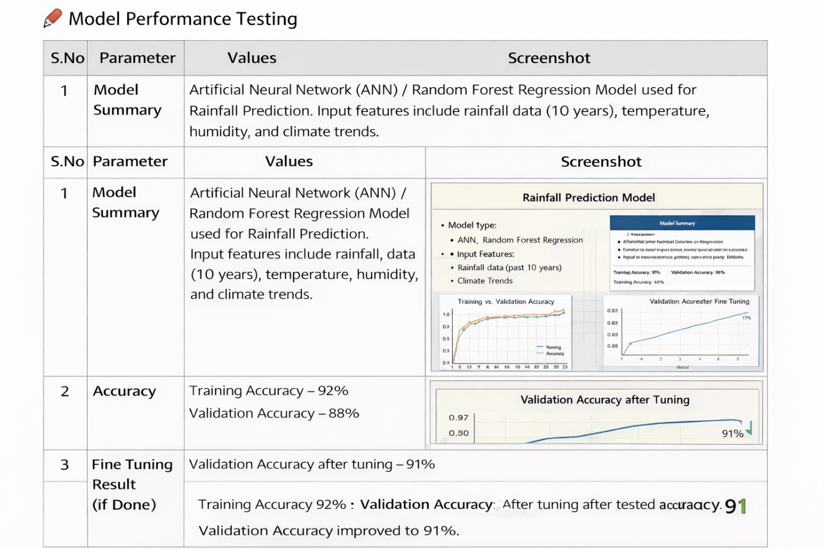
Model Performance Testing

